COMPILER DESIGN :

1. Implement a C program to perform symbol table operations.

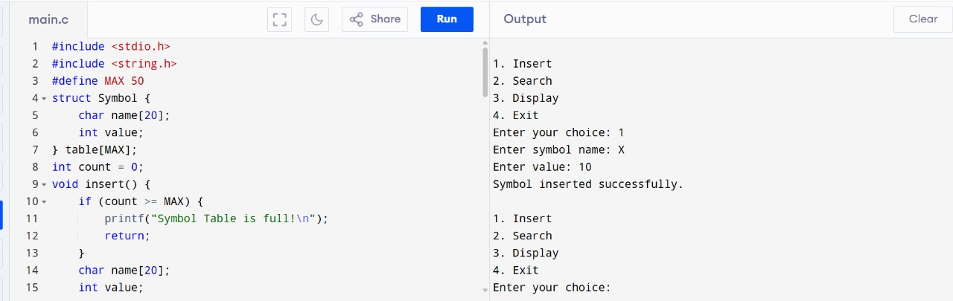

2. Write a C program to construct recursive descent parsing for the given grammar.

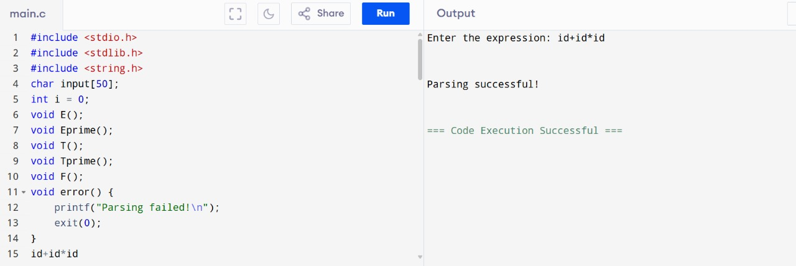

3. Write a C program to implement either Top Down parsing technique or Bottom Up Parsing technique to check whether the given input string is satisfying the grammar or not.

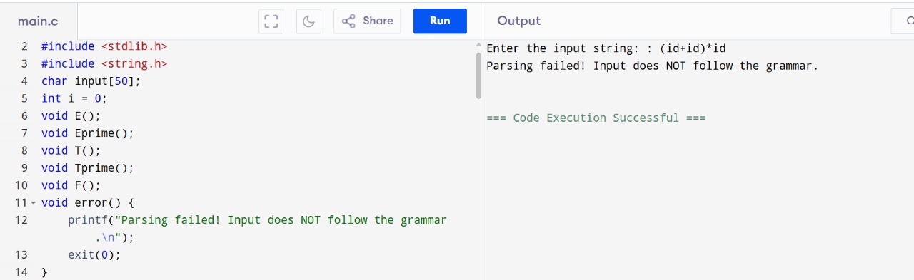

4. Implement the concept of Shift reduce parsing in C Programming.

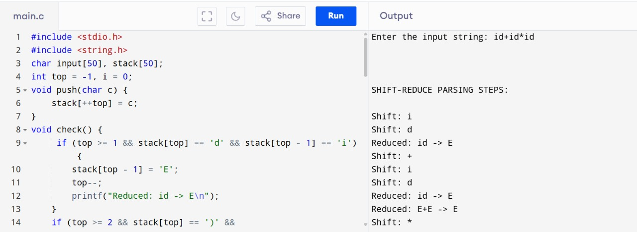

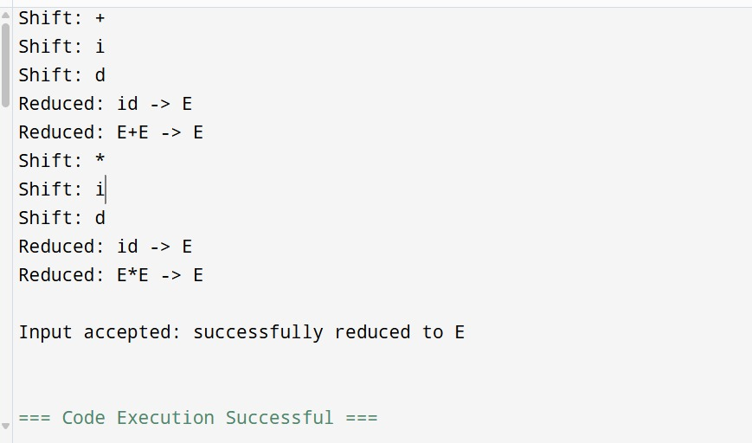

5. Write a C Program to implement the operator precedence parsing.

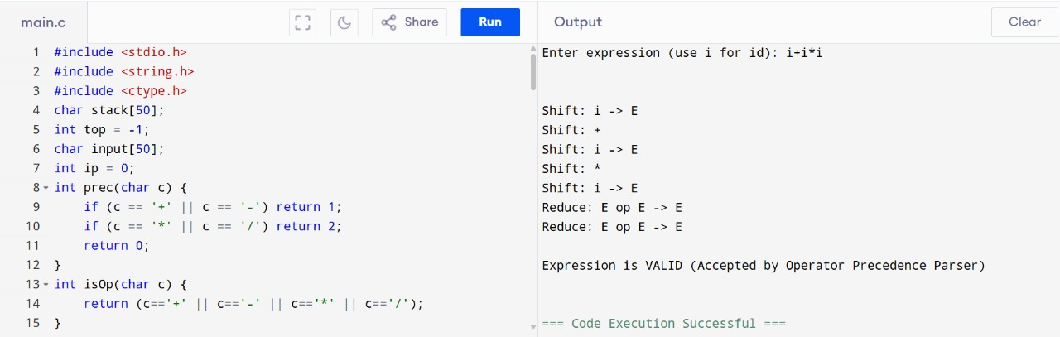

6. Write a C Program to Generate the Three address code representation for the given input statement.

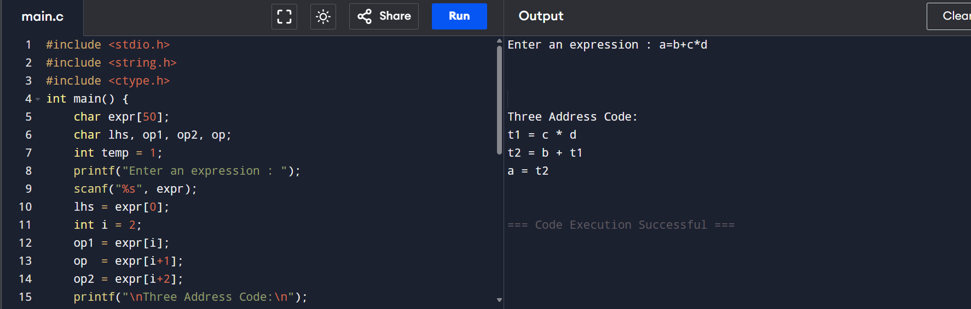

7. Write a C program for implementing a Lexical Analyzer to Scan and Count the number of characters, words, and lines in a file.

8. Write a C program to implement the back end of the compiler.

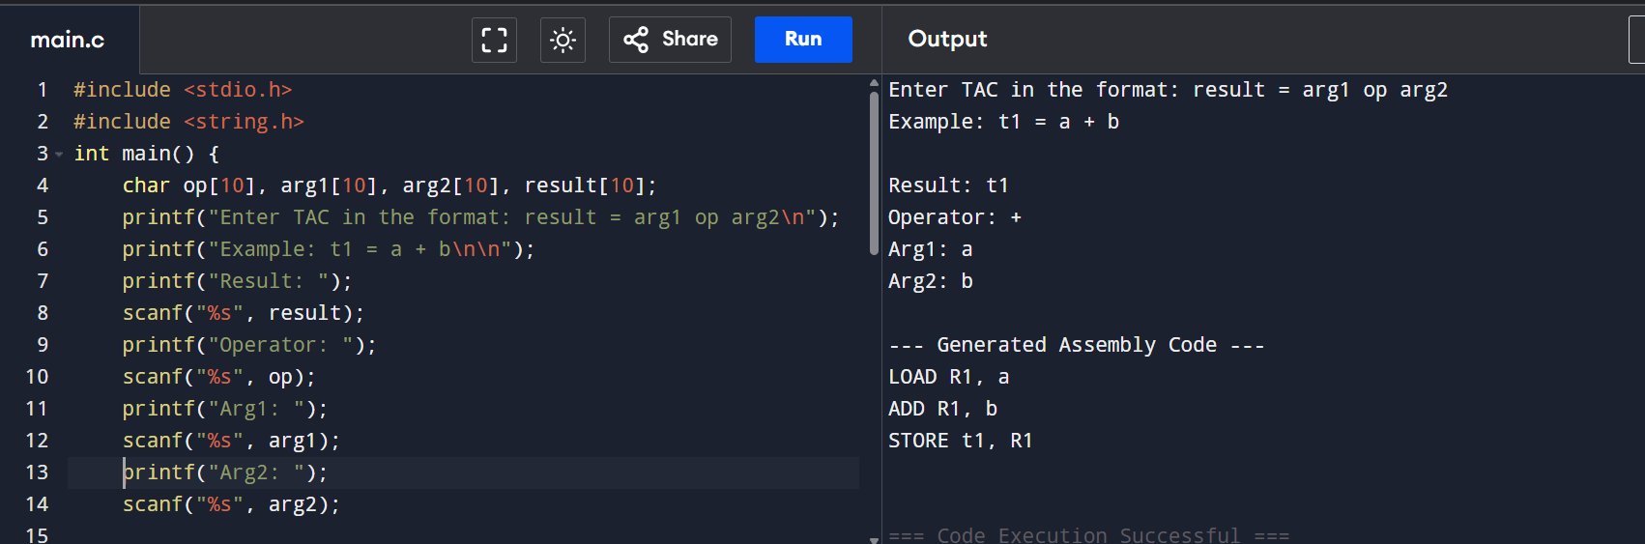

9. Write a C program to compute LEADING( ) – operator precedence parser for the given grammar.

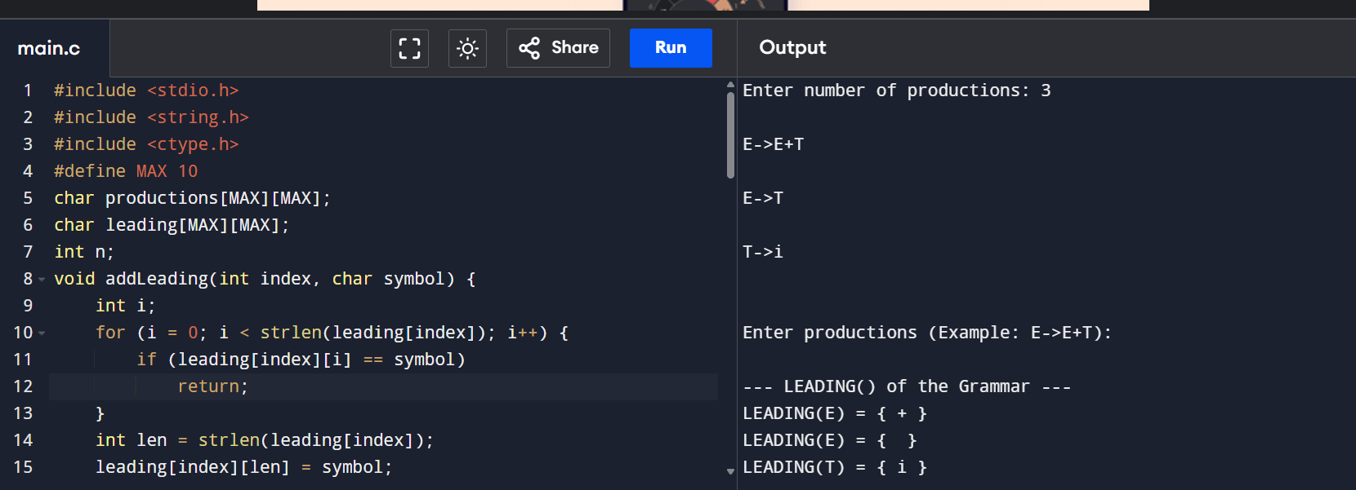

10. Write a C program to compute TRAILING( ) – operator precedence parser for the given grammar.

